NUCLEAR SPECTROSCOPY AT THE WWR-M REACTOR.
FUNDAMENTAL AND APPLIED INVESTIGATIONS

E.M. Korotkikh, Yu.E. Loginov, V.V. Martynov, S.Eh.Malyutenkova

Gamma transitions between the excited states of doubly even 118Sn in the energy range of
0.1 – 10 MeV were measured in the framework of the experiment aimed to the investigation of P-odd effects in the output channels of the 117Sn(n, γ)118Sn reaction with thermal neutrons. Energy values and absolute intensities of γ-lines were determined. The level scheme of ¹¹⁸Sn involving 46 excited states and 162 γ-transitions between them was constructed. Spin values and parities were assigned to all these states [1].
The absolute intensities of the 7.28 and 9.33 MeV γ-transitions were used for the interpretation of P-odd effect formerly observed for these γ-transitions [2]. The neutron binding energy in ¹¹⁸Sn has been determined as 9326.12(4) keV.
The photon strength function of twenty one M1 primary transitions (black circles) shown on the Fig.1. does not follow the E^{–3} dependence (see Eq.2 in [1]).

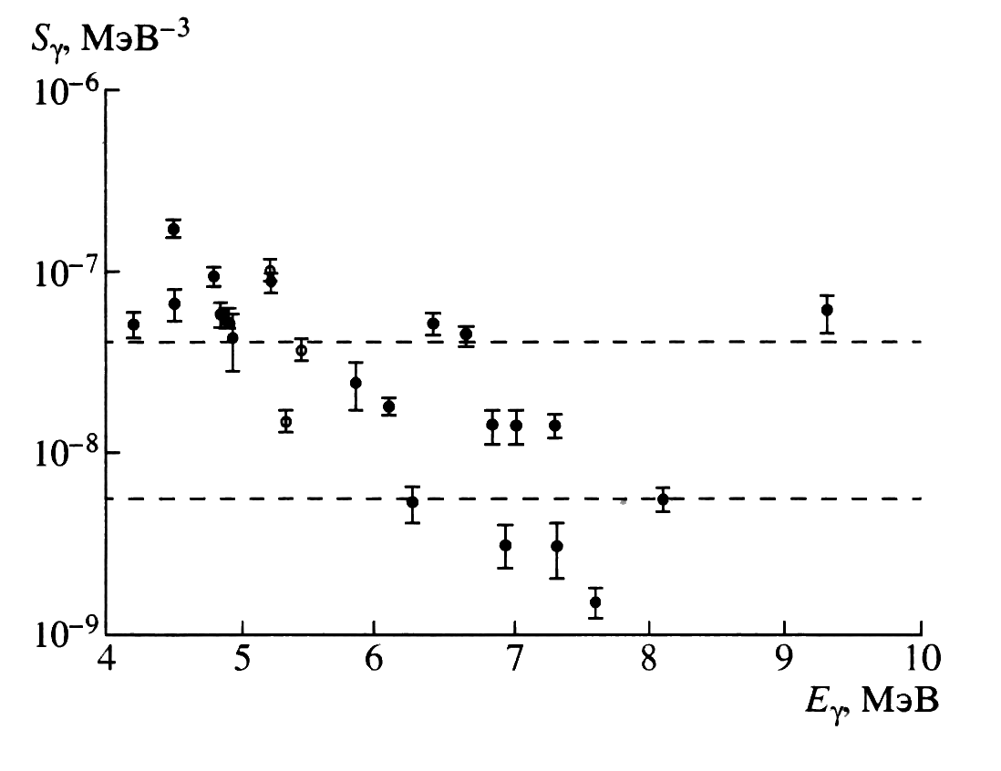
Fig. 1.

Measurement of heavy metal ions binding by yeast cells with TXRF spectrometer
The total reflection XRF method was used for quantitative determination of the ability of microorganisms to bind ions of heavy metals, e.g. of Sr and Cs [3].
The samples of yeast Pichia farinosa No 46 grown in the medium containing SrO and CsCl₂ taken for investigation are irradiated by X-rays and spectrum of secondary X-rays was measured by Si(Li)-detector.
The quantities of Sr and Cs bonded by yeast were obtained with method of inner standard. Gallium standard in concentration 10 mg/liter was introduced into the sample under investigation. Gallium was chosen because of it does not occur in natural and biological samples. The lower limits of the detectable concentrations of Sr and Cs were obtained to be 1.3 and 3 mg/liter correspondingly. The spectrum of biological sample with Cs and Ga standard is shown on Fig. 2.
Fig. 2.

The results of measurements show that the nature yeast strain could be used for bioremediation of industrial wastes solutions polluted by salts of heavy metals. The results could be a foundation for the developing a new technology for the concentration of heavy metals from the nature and industrial wastes.
The thermal neutron cross sections of the ¹⁴N and ¹⁹F were measured with targets consisted of mixtures of Pb(NO₃)₂, CaF₂, LiF and Teflon with Al₂O₃ [4]. Thermal neutron cross section of Al is known well (0.231(3)b). The γ-line with the energy 1779 keV from decay of ²⁸Al ground state (T_{1/2} ~3 min) which was used as γ-intensity standard, has the 100% branching ratio
(I_{γ} = 100%). This γ-line is observed in the measured γ-spectra in equilibrium with the capture radiations.
As result, the thermal neutron radiative cross sections of ¹⁴N and ¹⁹F were obtained to be 0.0795(13)b and 0.00950(15)b, respectively. These values are significantly more precise than formerly known ones – 0.0750(75)b and 0.0096(5)b, respectively.

World-wide intercomparison exercise
The INAA group of the NRD of PNPI is one of the participants of the worldwide intercomparison exercise.
Quality assurance and quality control cover a very broad discipline; there are numerous factors and methods that must be employed to validate data and ensure adequate analytical performance. An intercomparison exercise serves as such independent external assessment. This should be a continuous and regular process, not only to maximize the confidence in a particular data set, but also to maximize the confidence in an analytical process.
For nearly thirty years the Marine Environmental Studies Laboratory (MESL) of IAEA-MEL has conducted intercomparison exercises that have resulted in the preparation of reference materials (RMs) for the analysis of trace elements and organic compounds as part of its contribution to IAEA’s Analytical Quality Control Service.
In 2003, the sample material of marine sediments from the Algerian coast of the Mediterranean Sea was prepared and distributed to analytical laboratories worldwide. In total, 103 laboratories from 47 counties reported results for 48 elements defined with 28 different analytical methods. The wide range of methods employed permits a statistically valid comparison of the principal method used, particularly the instrumental methods following sample digestion and the “non-destructive” techniques such as neutron activation analysis and X-ray fluorescence. The results from the PNPI-INAA group for 28 elements were evaluated by IAEA-MEL [5]. For illustration, the reported values for Sm and Sr are graphically depicted in Fig.3. The laboratory code of PNPI-INAA group is 60.

[1] Loginov Yu.E. at al., Izv. of Russian Acad. of Sciences, ser.fiz., 66, No 10, 2002, p.1454 (in Russian).
[2] Smotritzky L.M., Yadernaya Physika, 64 2001. p.1501 (in Russian).
[3] Korotkikh E.M. at al., Preprint PNPI-2536, Gatchina, 2003, 13 p. (in Russian).
[4] Egorov A.I. at al., Nucl.Instr. and Meth. In Phis. Research A 545, 2005, p. 296
[5] Martynov V.V. in Rep. on the worldwide intercomparison.
IAEA/MEL/75, Monaco, July 2004

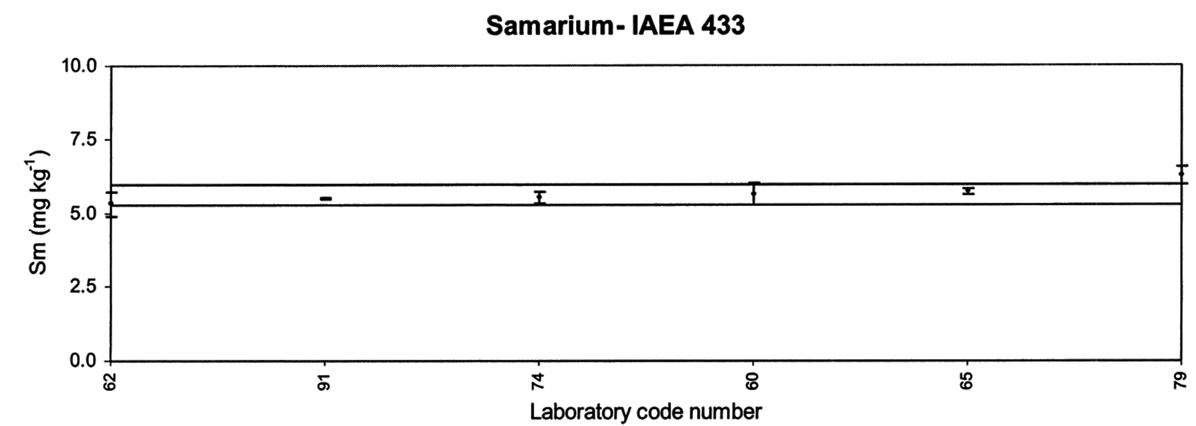

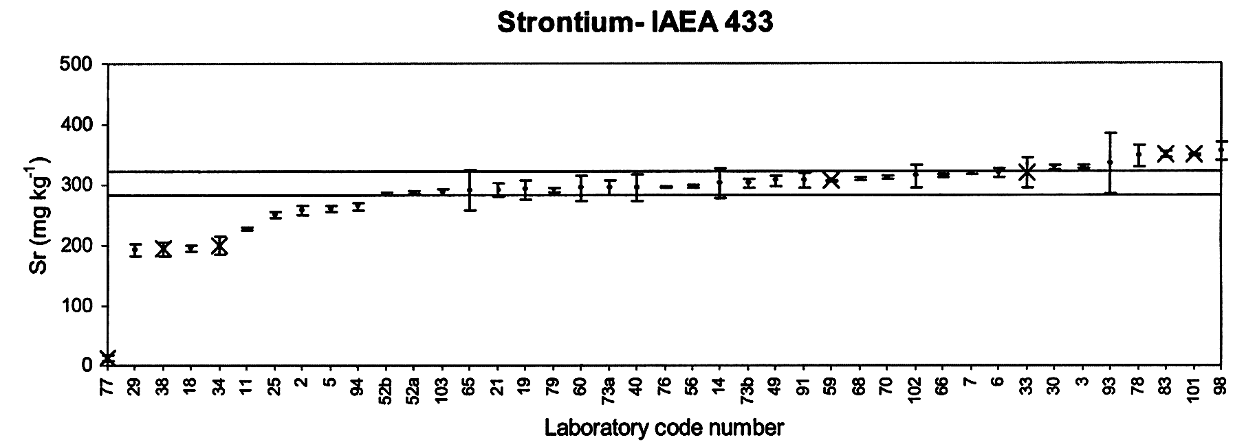

Fig. 3.

